**1. Create Two Storage Accounts and Create a Container Inside Them**

**Step 1: Create Two Storage Accounts**

1. **Log in** to the Azure portal.

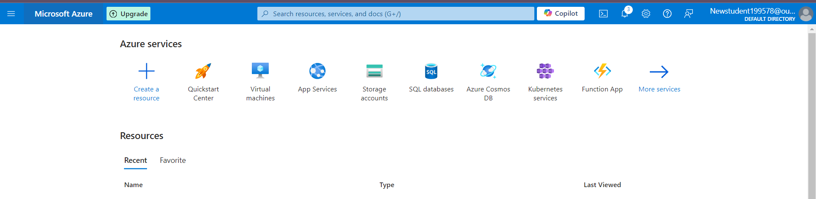

1. In the search bar, type **Storage accounts** and click on **Storage accounts** under services.

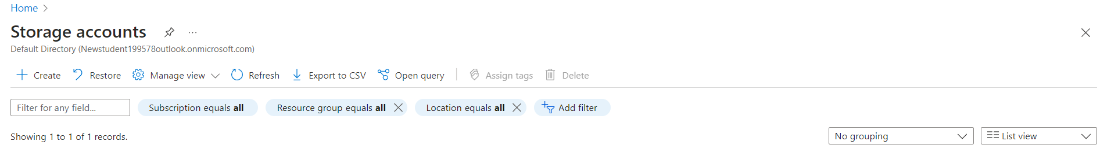

1. Click **Create**.
2. Fill in the necessary details for the first storage account:
   * **Subscription**: Choose your subscription.
   * **Resource Group**: Select an existing one or create a new one.
   * **Storage account name**: Enter a unique name for the first storage account (**shahidteam1**).
   * **Region**: Choose a preferred region.
   * **Performance**: Choose **Standard**.
   * **Replication**: Choose the replication type LRS.
   * Click **Review + Create** and then **Create**.
3. Repeat the steps to create the **second storage account** (**shahidteam2**).

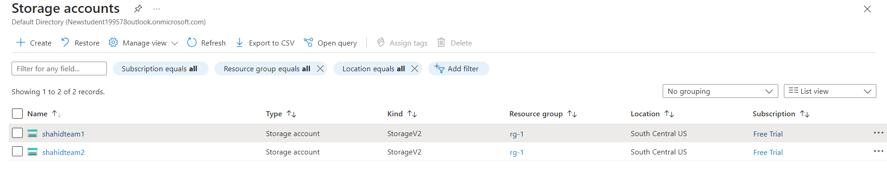

**Step 2: Create a Container Inside Each Storage Account**

1. Go to **Storage accounts** and click on the first storage account (**shahidteam1**).
2. In the left-hand menu, under **Data storage**, click **Containers**.
3. Click **+ Container** at the top, provide a name for the container (**shahidteam1container**), and select **Private** for public access.
4. Click **Create**.

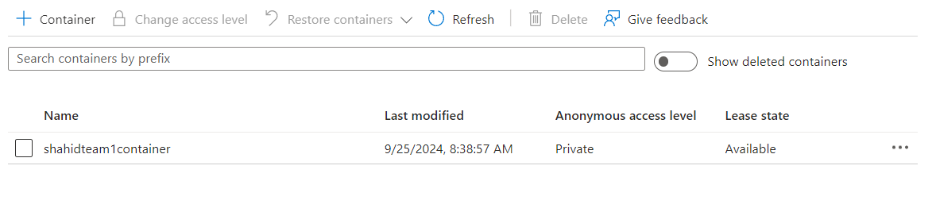

1. Repeat these steps for the second storage account (**shahidteam2**) and create another container (**shahidteam2container**).

**2. Upload Some Data to the First Blob Service**

1. Go to the first storage account (**shahidteam1**).
2. Under **Data storage**, click on **Containers**, and select **shahidteam1container**.
3. Click on **Upload** and select the files you want to upload to the Blob storage.
4. Click **Upload** to complete the process.

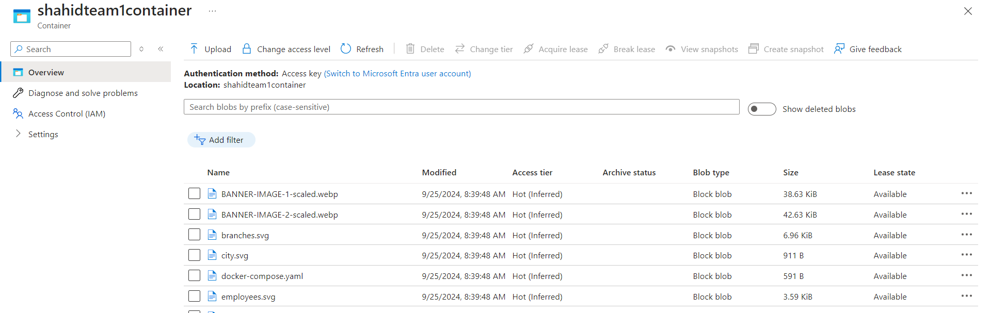

**3. Using Data Factory to Copy Data to the Second Storage Service’s Container**

**Step 1: Create an Azure Data Factory**

1. In the Azure portal, search for **Data Factories** and click **Create**.
2. Fill in the details for the Data Factory:
   * **Subscription**: Choose your subscription.
   * **Resource Group**: Select the same resource group or create a new one.
   * **Region**: Choose the same region as the storage accounts.
   * **Name**: Enter a unique name (**shahidteammydatafactory**).
   * Click **Review + Create** and then **Create**.

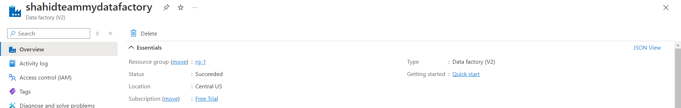

**Step 2: Create Linked Services for Storage Accounts**

1. Open **Azure Data Factories**.
2. In the Data Factory UI, click on the **Manage** tab on the left.
3. Under **Connections**, click **Linked Services** and then **New**.
4. Select **Azure Blob Storage**, and for the **Connection**:
   * Select your first storage account (**shahidteam1**), and connect using **Account Key**.
   * Repeat this process to create a linked service for the second storage account (**shahidteam2**).

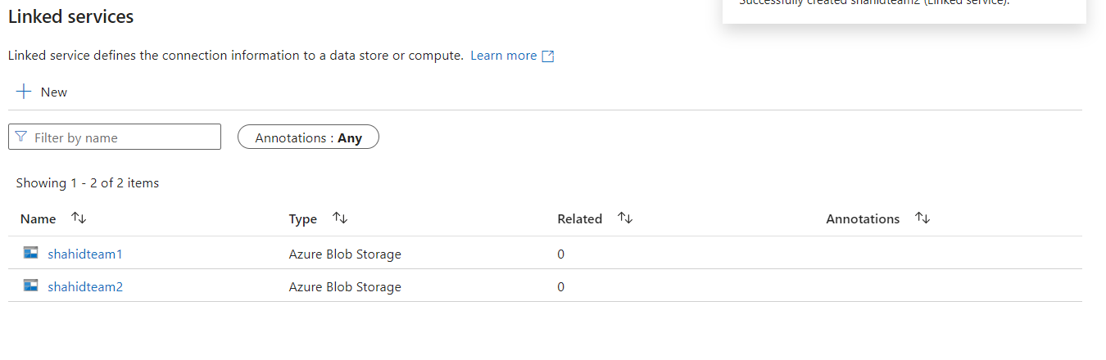

**Step 3: Create a Copy Data Pipeline**

1. Click on the **Author** tab in the Data Factory UI.
2. Under **Pipelines**, click **+ New pipeline**.
3. In the **Activities** pane, drag the **Copy data** activity onto the pipeline canvas.
4. In the **Source** settings:
   * Choose **Blob Storage**.
   * Select the first storage account (**shahidteam1**) and **shahidteam1container** as the source.
5. In the **Sink** settings:
   * Choose **Blob Storage**.
   * Select the second storage account (**shahidteam2**) and **shahidteam2container** as the destination.
6. Configure other options like file format and hit **Debug** or **Trigger Now** to start the copy operation.

